**Project Report Template**

**INTRODUCTION:-**

* 1. **Overview**
* **Event Management when compared to other traditional professions such as medicine, law and accounting is relatively a young field. It is an area that is growing rapidly and now represents hundreds of professionals who are responsible for planning, coordinating and evaluating a wide range of events all year round.**
* **Event management is predominantly about creating an experience. Bearing in mind that first impressions last, it is important when embarking on any event regardless of its scale to take the correct approach and use the right techniques to ensure that your event is successful.**
  1. **Purpose**
* **To reserve a room and request room set-ups, equipment management, technology and catering needs for all events including large-scale or high profile events**
* **To avoid double-booking and room schedule conflicts**
* **Assess and report usage and planning for the following year**
* **To effectively communicate campus event activity to all stakeholders and constituents**

**2.Problem Definition and Design Thinking:-**

**2.1 Empathy Map**

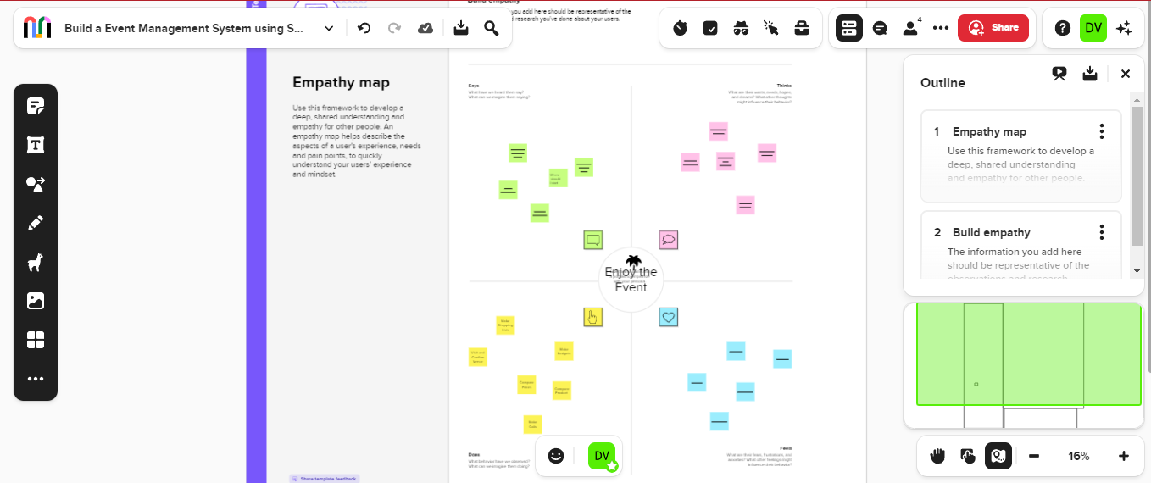

**2.2 Ideation and Brainstorming map Screenshot:**

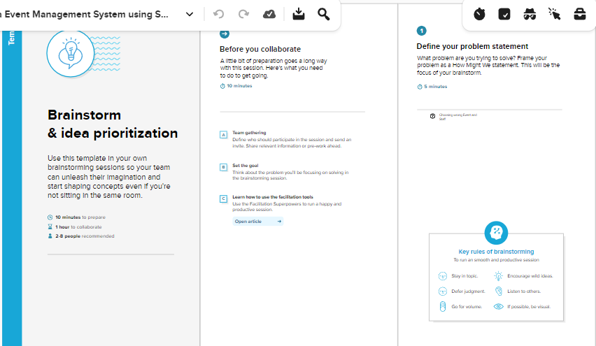

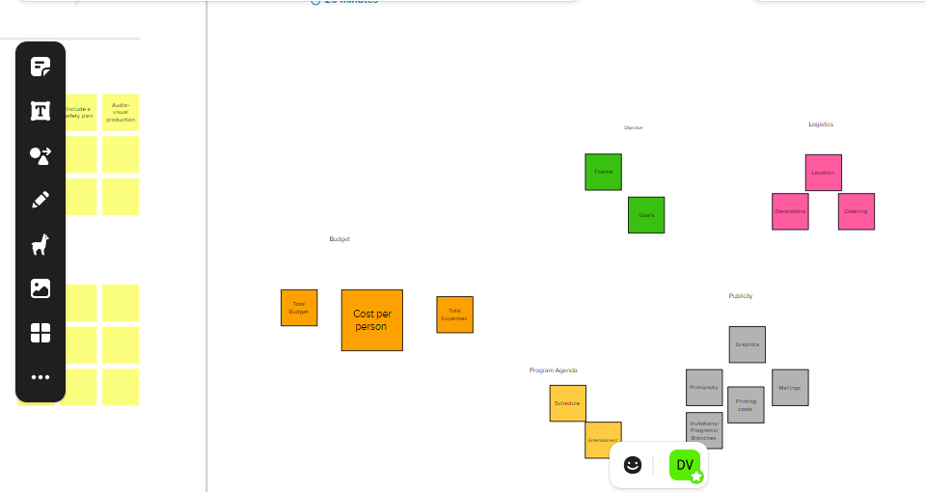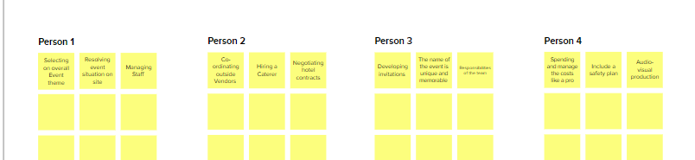

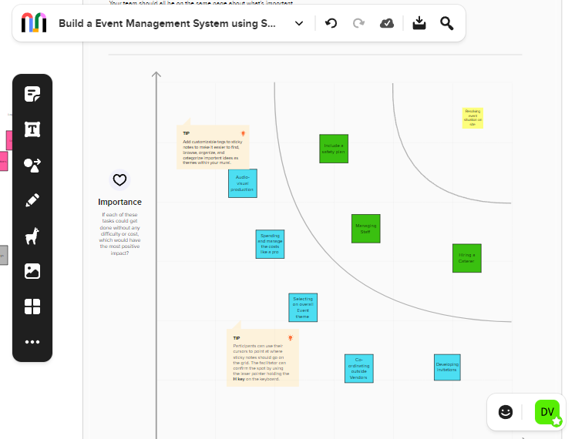

**3.RESULT:-**

**3.1 Data Model:**

|  |  |
| --- | --- |
| **Object name** | **Fields in the Object** |
| **Object-1** | **Field Label: City**  **Data Type: Text** |
| **Object-2** | **Field Label: Phone number**  **Data Type: Phone** |
| **Object-3** | **Field Label: Start Date**  **Data Type: Date\time** |

**3.2 Activity and Screenshot:-**

**Create Salesforce Org-Creating Developer Account**

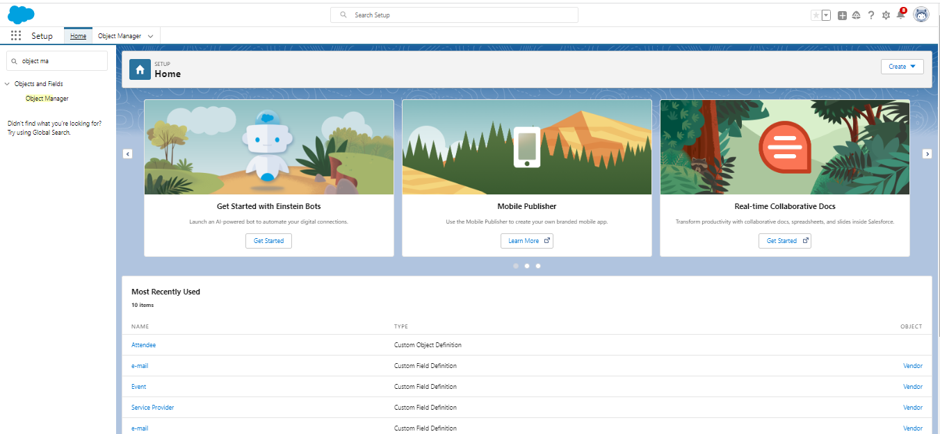

**Object:**

**Creation of Event Objects**

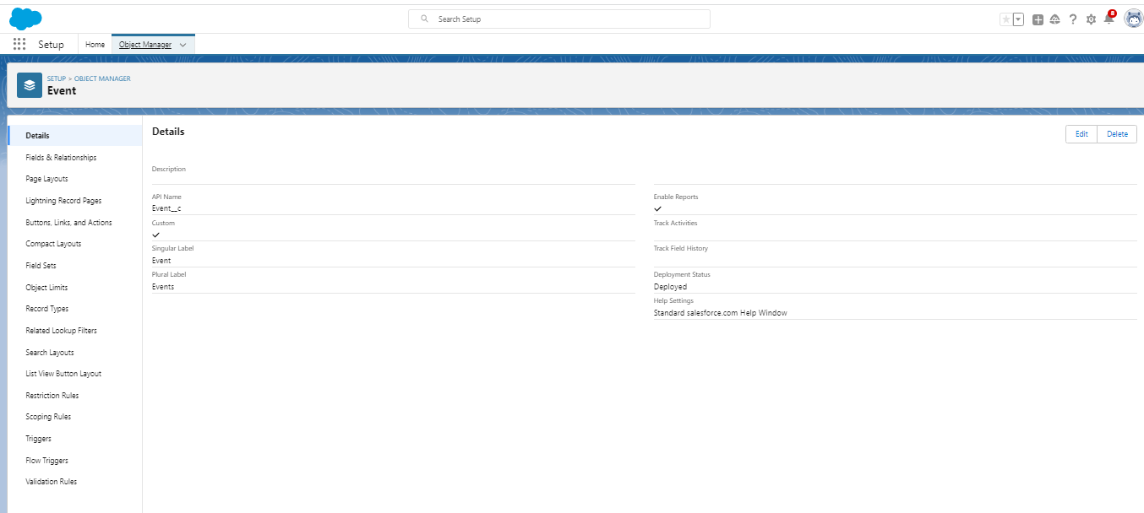

**Creation of Attendees Object**

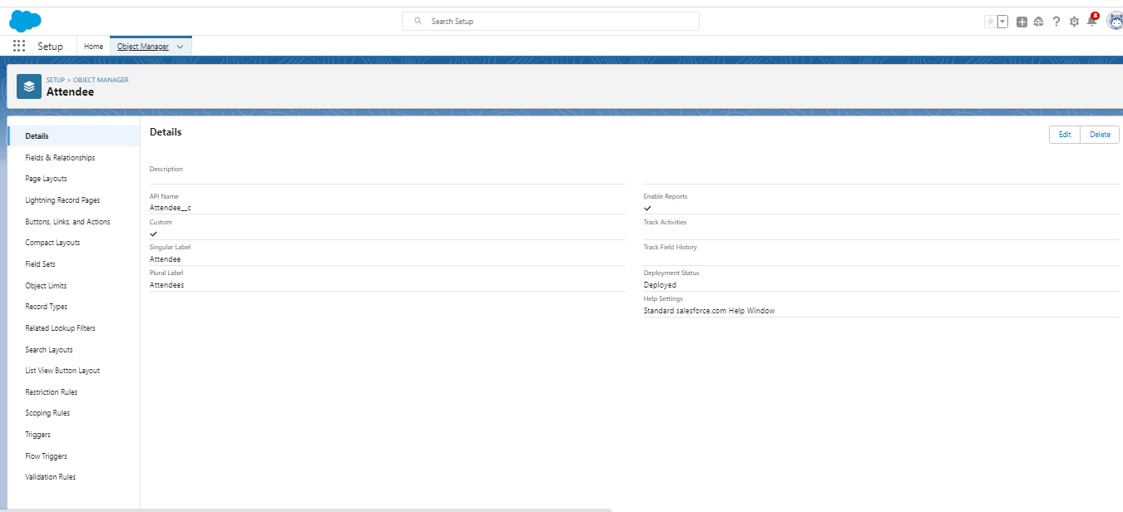

**Creation of Vendors Object**

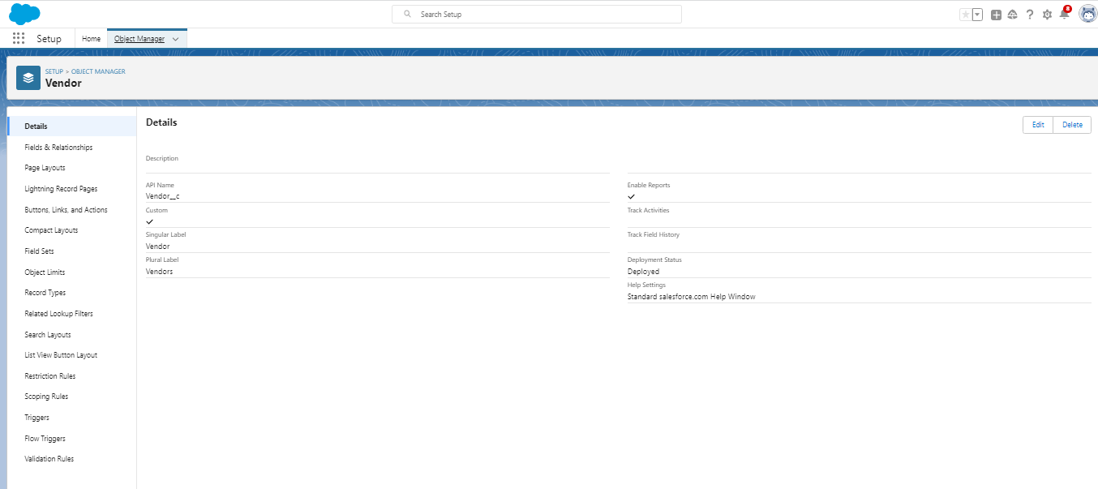

**Creation of Speaker Object**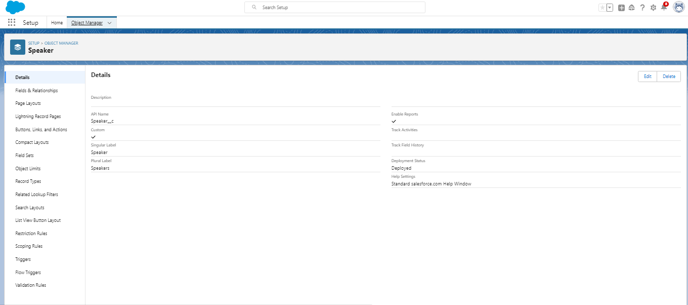

**Tab:-**

**Creation of Event Tab**

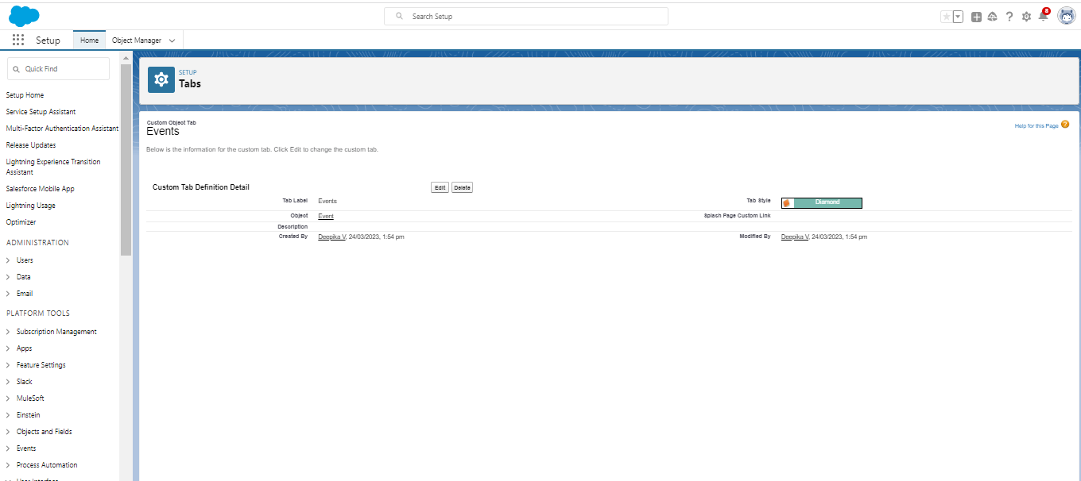

**Creation of Attendee Tab**

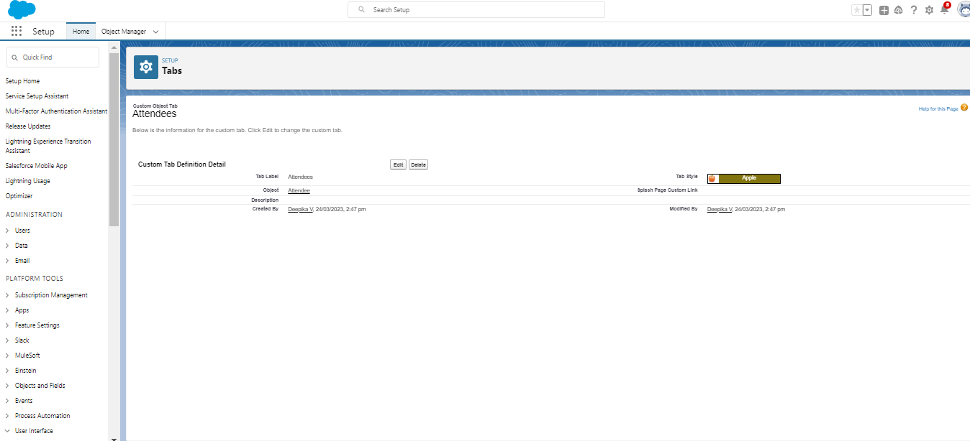

**Creation of Speakers Tab**

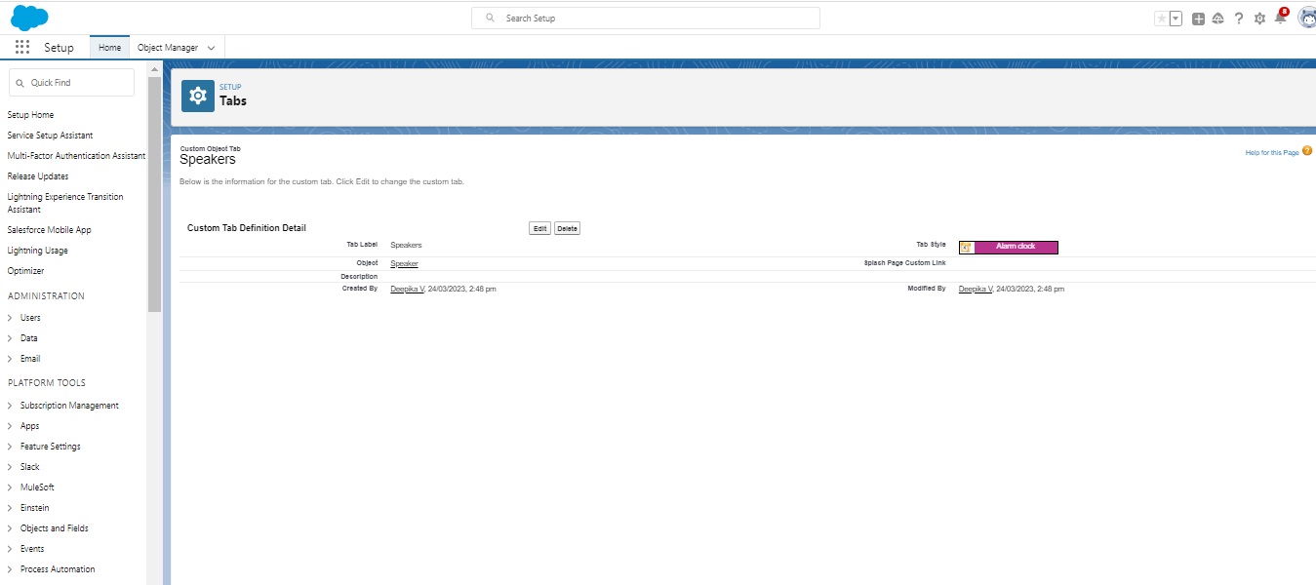

**Creation of Vendor Tab**

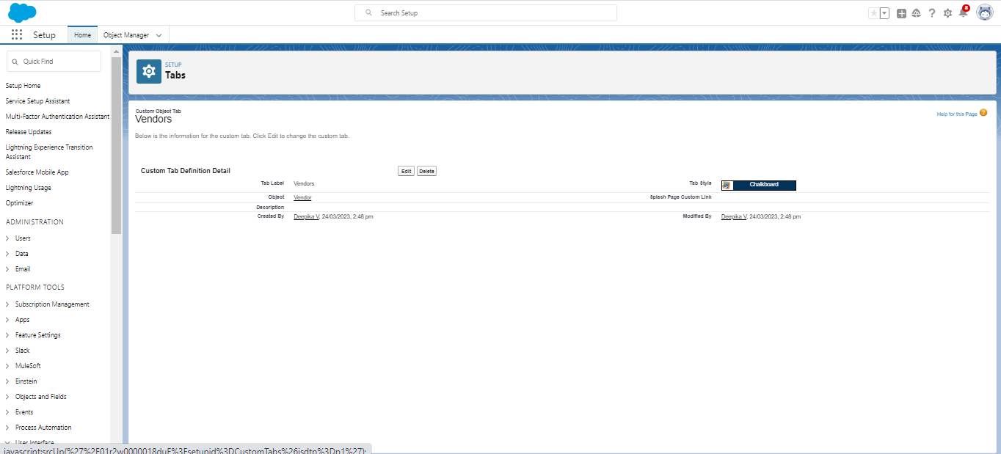

**Application:-**

**Create The Event Management Construction App**

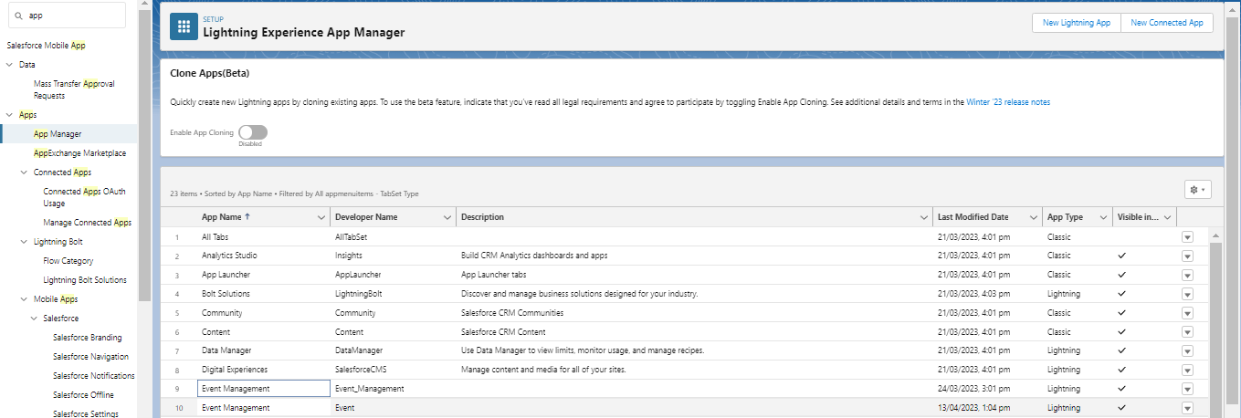

**Fields:-**

**Creation of fields for the Event Objects**

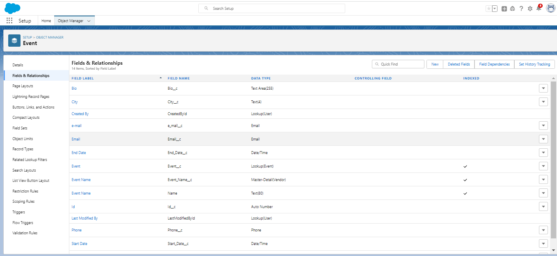

**Creation of fields for the Attendees Object**

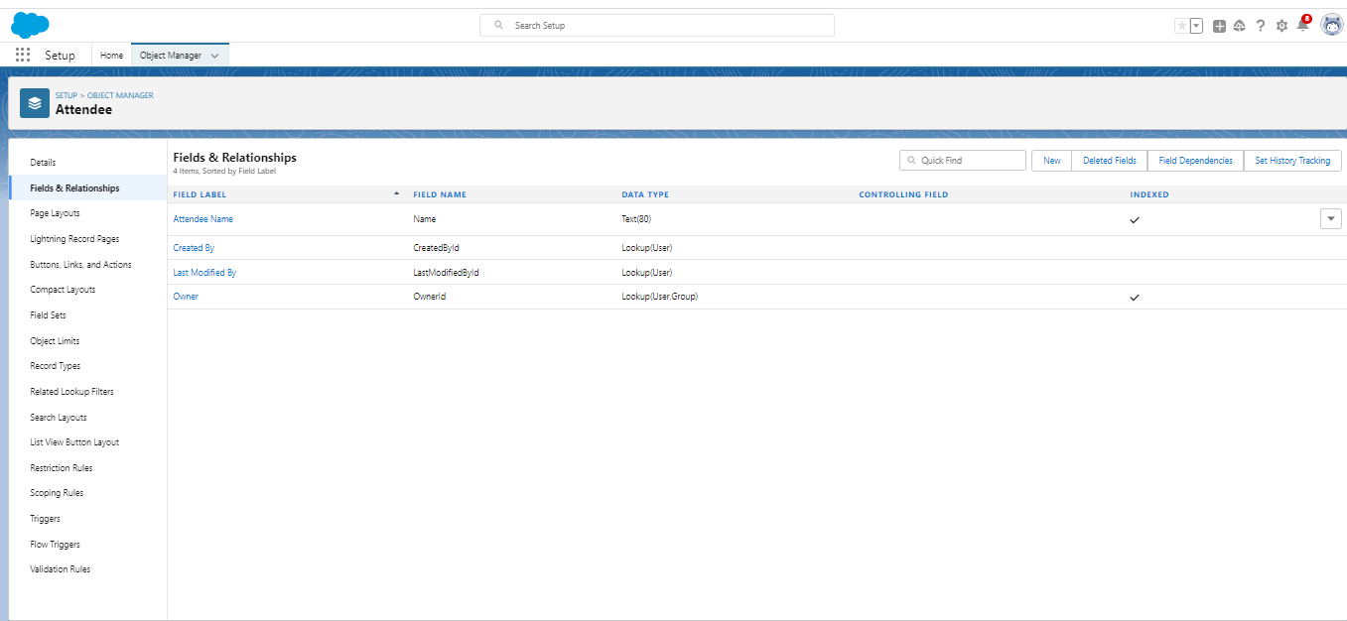

**Creation of fields for the Speakers Objects**

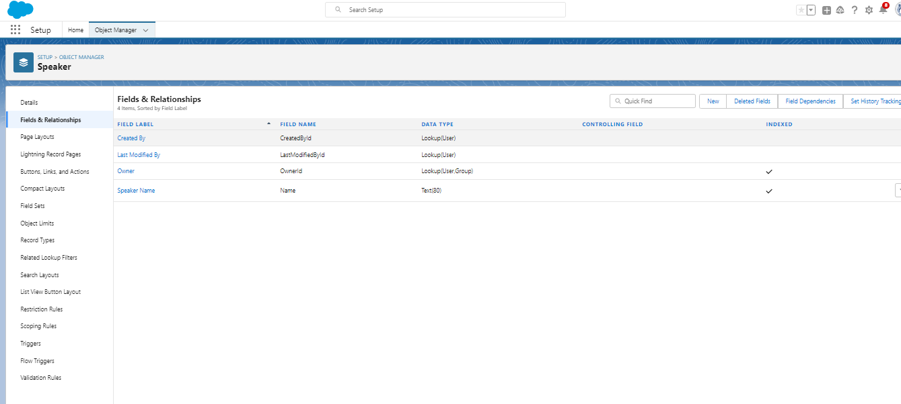

**Creation Field for the Vendor Object**

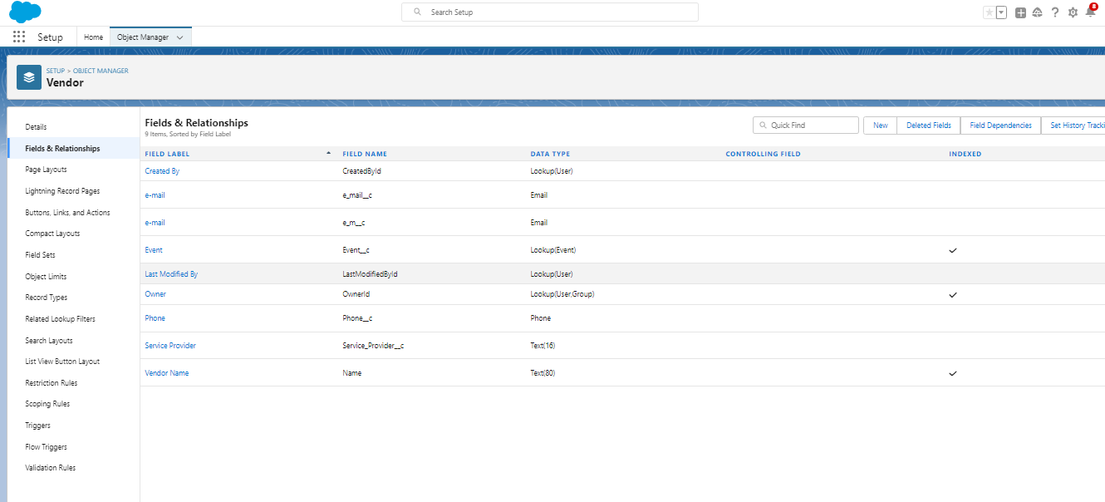

**Profile:**

**Creation on Profile**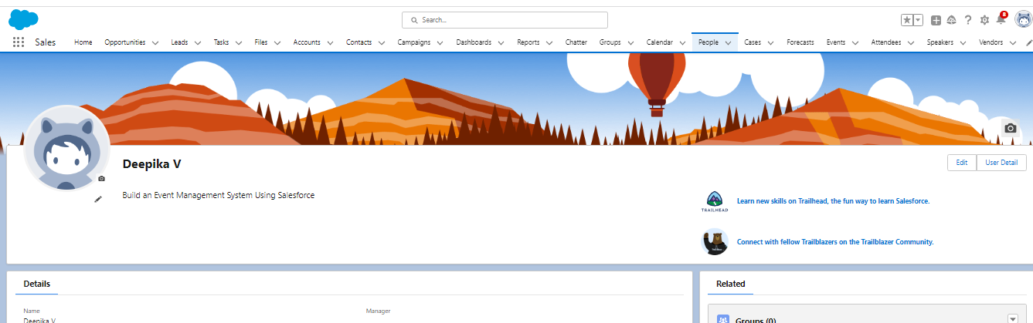

**Users:**

**Creating A User**

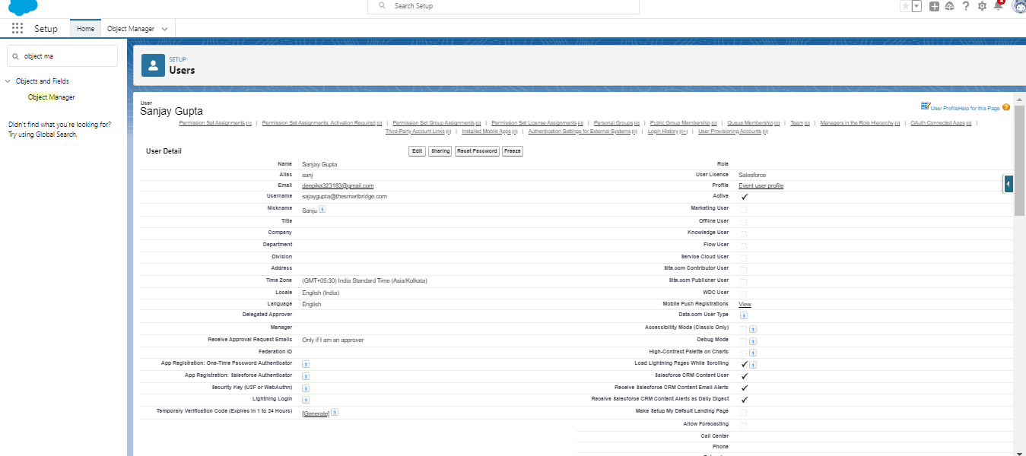

**Permission Sets:**

**Creating A permission set**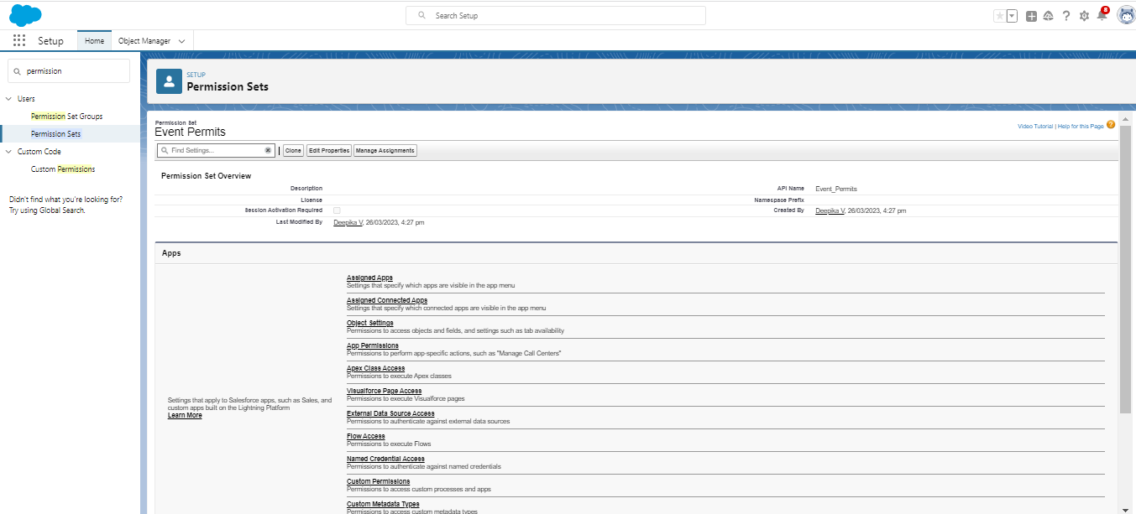

**Reports**

**Creating A Reports**

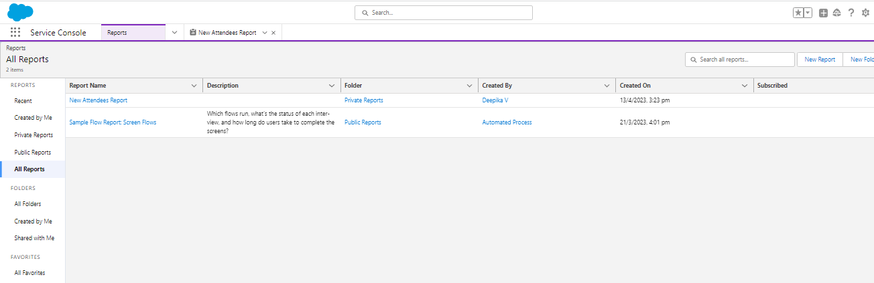

**4.Trailhead Profile Public URL**

**Team Lead-**

**Team member 1-**

**Team member 2-**

**Team member 3-**

**5. ADVANTAGES AND DISADVANTAGES**

**1.Increased engagement**

Engagement is at the heart of every event, whether it is business or casual. It needs to start early before the event even begins. While during the event, it is essential, the activities must be engaging, it is also crucial that the engagement of visitors increases as the event proceeds further.

A useful event management tool will enable you to aid participant communication at all stages. It also comes with the ability to view all the data accumulated and analyze it after the event gets over.

**2.Supports targeted activity**

Marketing is highly effective when it is targeted and tailored toward an individual. The data accumulated from past events can be used to know that the individuals that are visiting the event might be looking for.

**3.Document Generation**

The event planning software offers you the ability to generate electronic documents related to all your marketing campaigns. You can print essential documents such as Chef BEOs, Credit card authorization forms, Proposals, Menus as well as invoices. It can also generate automatic contracts outlining details such as Client names, event dates, guest numbers, company policies, and other related information**.**

**4.Price**

The cost varies significantly for event planning software, and as more features are added, the price also increases

**5.Lack of design options**

With the ease of using any software, there often comes the cost to pay of losing some vital customization features. The users also find that features are not as intuitive as they need to be**.**

**6.Support Channels**

The customer service provided with any software is essential, as in case you run into any technical problems, it can affect your event planning.

**APPLICATION:**

An Event Management System (or Event Management Software) helps organizers plan, execute and reports on events, driving success for their business**.**

**CONCLUSION:**

Event Management System is **user friendly and cost effective system**, it is customized with activities related to event management life-cycle.

Event Management is **the application of project management to the creation and development of festivals, events and conferences**. Event management involves studying the intricacies of the brand, identifying the target audience, devising the event concept planning the logistics and coordinating the technical aspects before actually executing the modalities of the proposed event.

**FUTURE SCOPE:**

Event Management System can be further enhanced in the future by adding more customer service to the customer through Online Ticket Reservations for participating in the events. The application can communicate to other event business application which can be enhanced to distribute the business data and serve as a broker between the Customer and the Business Entity. Online payment services will be the most added advantage for the customer to make their payment through Credit Card Transaction. The application developed is designed in such a way that any further enhancements can be done with ease. The system has the capability for easy integration with other systems. New modules can be added to the system with less effort.

Event Management System will be enhanced further with automated mailing services to the customer.